

The Executive Summary

Prepared for:
Nuance Communications, Inc

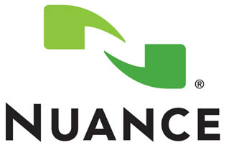

Presented By:
Brown & Brown Insurance of Georgia
C. Blake Cescutti, CIC, CRIS

**The information contained in this document is confidential and privileged information**
Table of Contents

I. Introduction a. Scatter Analysis 3

II. Back-Up of Sewer or Drains Exclusion
a. What’s it Cover? 4
b. What Cause’s Back-Ups? 4
c. Consequences of Inadequate Coverage 5
d. How to Determine Coverage Amount 5
e. Recommendations 5
f. Current Policy Exclusions 6
g. Claims Examples 7

III. Employee Dishonesty Sub-Limit
a. What’s it Cover? 8
b. How to Determine Coverage Amount 8
c. Consequences of Inadequate Coverage 9
d. Recommendations 9
f. Current Policy Sub-Limit 10
g. Claims Examples 11

IV. Utility Services Interruption
a. What’s it Cover? 12
b. Know your Coverage 12
c. Consequences of Inadequate Coverage 13
d. Recommendations 13 f. Current Policy Limitations 14
g. Claims Examples 15-16

V. Problematic Deductibles
a. Defining Deductibles 17
b. Know Your Deductibles 17
c. c. Consequences of Inadequate Coverage 18
d. Recommendations 18 f. Current Policy Limitations 19-23
g. Claims Examples 24

Introduction

Brown & Brown, Inc. is recognized as one of the largest and most respected independent insurance intermediaries in the nation. With over 74 years of continuous service, Brown & Brown is ranked the seventh largest insurance intermediary in the world by U.S. business by Business Insurance magazine as of July, 2011. Brown & Brown’s reach includes over 37 states and offers insurance programs and services through their 200+ Retail, Brokerage, National Programs and Services offices throughout the country.

Our Method:
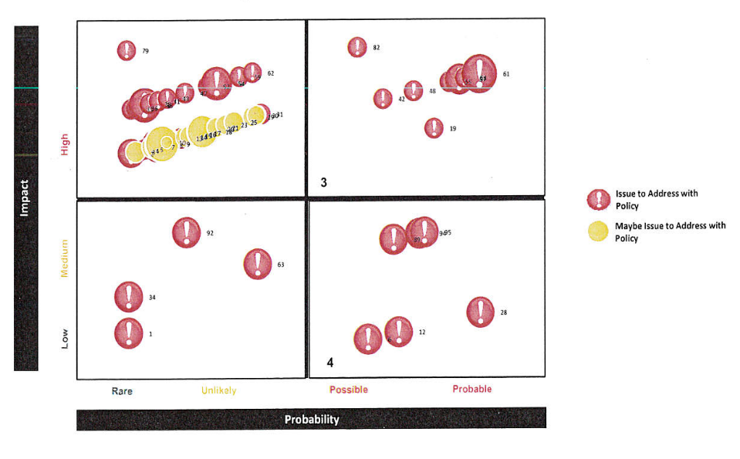

Our process is designed to identify areas of improvement within insurance policies to make certain your premium dollars are maximized. We reviewed approximately 91 different areas within your policies and found approximately 29 areas of improvement. The 5 areas we are discussing today and highlighted on the following pages may not be any more important than another.

(Disclaimer: Please refer to the actual policies for terms, conditions and coverage)

Back-Up of Sewer or Drains
What is this Coverage For?
Just because you have flood coverage does not mean that back up of sewers and drains is covered. These are very different types of occurrences and each require specific insurance coverage. A flood involves rising waters, such as those caused by rain, melting snow, or overflow of a river. Sewer or drain backup, results from water that causes damage to your commercial property as a result of a sewer or drain backup.
This coverage is very often provided to an insured, typically with a sub-limit of $25,000 or less. And typically the cost to go to a higher amount is nominal.
These sub-limits are very often overlooked by the typical “copy cat” broker, and the insured does not have enough coverage. Remember: many times this additional coverage or coverage enhancement is used by the carrier to beef up their product. They are typically window dressing coverages and you need to understand the true exposure.
What Causes Back-Ups?
Many perils can cause back up of sewers and drains, such as excessive rain, blockage in pipes, and failure of equipment and this may NOT be covered by a flood policy, depending on the facts of the loss.
- Blockages due to Tree Roots: Shrubs and trees seeking moisture can make their way into sewer line cracks causing extensive damage. They may start out small, getting into a small crack in the pipe; but as the tree or shrub continues to grow, so does the root. Tree roots can enter the service pipe at joints and cause blockages. They can also travel a long way, and roots from different types of trees act differently. If you suspect that city trees are responsible for sewer line damage, your plumber can contact the city and samples of the roots will be used to help identify the trees and who is responsible for cleanup. Sometimes a blockage is the result of a combination of city and private trees. In this case costs are split between the city and property owner.
- Sanitary Main: A blockage can occur in a city sanitary main. If the blockage is not detected in time, sewage from the main can back up into homes and businesses through floor drains. Usually this happens slowly, giving the owner time to call a licensed plumber to assess the damage. If water is entering your basement at a rapid rate, call the city public works office and report the problem immediately so that a city operator can investigate. Source for causes of sewer back up: Insurance Information Institute.
Consequences of Inadequate Coverage
Damage in excess to the insurance policy sub-limit – hit to balance sheet
An uncovered or partially covered loss is especially painful when the insured discovers the reason the loss is not covered, is that his or her broker never brought it up. This fact coupled with the fact that the cost to increase the sub-limit, in most cases, is nominal, is a painful combination.
Having the Right Amount of Coverage for You!
It is very important to review each and every situation differently from the next when deciding on the proper coverage limit for Back-Up of Sewer or Drains. You must understand the exposure completely, and discuss with your insurance agent and risk manager all the possibilities of a “worst case scenario loss”. Together WE can determine an adequate limit.
Using the steps listed below, you can properly determine the appropriate coverage limit:
- Understand the exposure and select the best limit with your insured.
- Do they have equipment stored in a basement?
- What is the insured’s viewpoint on the exposure?
- What do they think is the worst case scenario?
- Make sure you have documented cases that the prospect can relate to.
- Do some research with the county or a contractor and find out how often the sewers and drains are backed up.
- Are there certain areas prone to this type of loss—can you market in this area?
- Could mold also be a concern?
Brown & Brown Recommendations
After reviewing your current policy written with Marsh USA, we have found that your current policy limit for Back-Up of Sewer or Drains is ZERO COVERAGE. This limit is provided by the “Basement Water Exclusion” and the “Surface Water or Back-Up Exclusion” added to your policy.
Any property located in the basement or, the first floor at your Melbourne location, is subject to water damage due to water back up from a sewer or a drain. After reviewing your property schedule, I noticed that there is over $8,000,000 is personal property and $2,000,000 in computer hardware at your Melbourne, Florida location, with ZERO COVERAGE for water back-up. This leaves your balance sheet completely vulnerable should a loss occur.

You could literally be up
$@!+ Creek without a paddle.

Exclusions in Current Policy
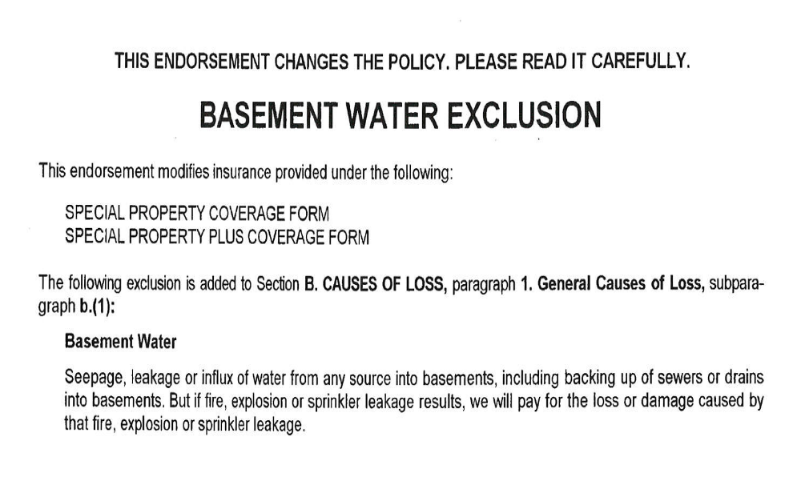

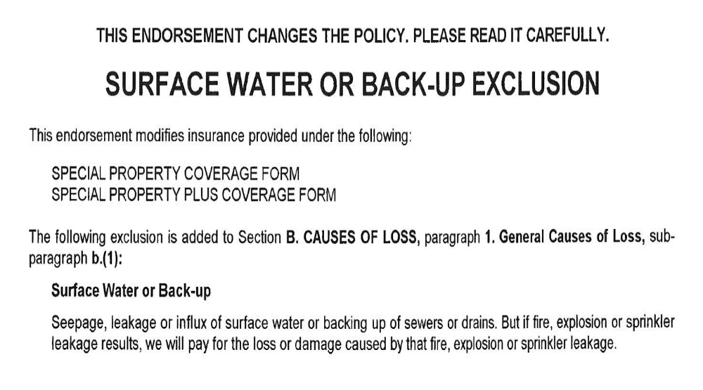
Sewer Back-Up Claim in the News

Commercial Insurance: Property Insurance

Water Damage ~ if water backs-up through my sewer or drain am I covered?
Nearly all property forms, including Homeowners policies, exclude or restrict water damage caused by the backup of sewers or drains. The provisions vary from company to company but usually read like in SECTION I – PROPERTY EXCLUSIONS, that water damage is excluded if caused by:
Water or water-borne material which backs up through sewers or drains or which overflows or is discharged from a sump, sump pump or related equipment.
This exclusion is talking about “overflows” of water from sewers (like out of toilet bowls) and “backups” from drains (like floor drains and sinks). The source of the water or sewage may be “off premises” from a plugged public sewer system or caused by water inside the home that is left on or stuck on which overwhelms a drain system that is plugged or restricted.
NOTE: Coverage for sewer or drain water backup can be added by endorsement for a small additional premium. AMERICAN INSURANCE highly recommends that all Homeowner’s policies be endorsed with sewer and drain water backup coverage. These type of claims can be costly to cleanup and repair. Review your policy with your agent to determine what coverage, if any, is currently provided.
Why do Homeowners and other property forms exclude coverage for sewer or drain water backup?
1. Water backup losses are extremely common but preventable with maintenance and preventative measures by the home owner. Water losses from plugged up toilets and clogged up drains can be prevented or minimized when home owners are observant and promptly repair sticking toilet bowls and clogged, slow running drains.
2. Water systems require periodic maintenance or reinvestment by the home owner. Over time, every water drainage system becomes restricted with rust, deposits and accumulated debris. Drain fields become saturated and tree roots interfere with drainage. Without preventative maintenance, slow running drains won’t handle normal water flow or plug up completely.
3. Off premises sewage backups can be prevented with the installation of drain backflow preventers that are installed on your drain line. Unfortunately, many older homes did not have these preventers installed.
4. During flooding the water table rises and first causes water backup through sewers and drains. Since “flood” is an excluded coverage, the unendorsed Homeowner’s policy has this exclusion.

Employee Dishonesty Sub-Limit
What is this Coverage For?
Just because you have the most efficient and friendliest of employees, does NOT mean that they are the most honest of individuals. In fact in most employee theft case, the dishonest employee is well tenured, a close friend, and sometimes even a family member. An employee can walk away with thousands before anyone can even notice. Here are some examples:
- Embezzlement
- Theft of Money
- Theft of Tools, Computers, or Hardware
- Forgery and Alterations
This coverage is very often provided to an insured, typically with a sub-limit of $25,000 or less. And typically the cost to go to a higher amount is nominal.
These sub-limits are very often overlooked by the typical “copy cat” broker, and the insured does not have enough coverage. Remember: many times this additional coverage or coverage enhancement is used by the carrier to beef up their product. They are typically window dressing coverages and you need to understand the true exposure.
What is YOUR Exposure?
Many things can be considered an employee dishonesty claim. In fact there are number of different causes that will trigger such a claim. The idea is to be prepared, be observeative, and not get caught off guard. Knowing what your risks and exposures are will prove to be vital.
Using the steps listed below, you can properly determine the appropriate coverage limit:
- Understand the exposure and select the best limit with your insured.
- What is the insured’s viewpoint on the exposure?
- How many employees have access to financials?

- What do they think is the worst case scenario?

Protect your Money,
YOU earned it!!

Consequences of Inadequate Coverage
Loss in excess to the insurance policy sub-limit – hit to balance sheet
An uncovered or partially covered loss is especially painful when the insured discovers the reason the loss is not covered, is that his or her broker never brought it up. This fact coupled with the fact that the cost to increase the sub-limit, in most cases, is nominal, is a painful combination.


Brown & Brown Recommendations
After reviewing your current policy, I have determined that you have a small limit of $50,000 for all employee dishonesty claims, which also holds a $10,000 deductible. This limit is substantially inadequate for a business of your size. And to add insult to injury, if an employee steals form you, your current insurance agent says you are responsible for the first $10,000.


Slap in the face!!

I have noticed that you have over 1,000 employees worldwide, with receipts totaling over $750,000,000, at over 15 different locations. This could be overwhelming for even the best accounting department to manage, and keep track of. Someone as large as you are is a prime target for even the smallest amount of embezzlement, misuse of funds, or employee theft. I recommend that we first look at your accounting procedures, financial statement, and determine just how vulnerable your balance sheet truly is. Don’t be shocked if we determine you should have $250,000 in employee dishonesty coverage!

Sub-Limit in the Current Policy
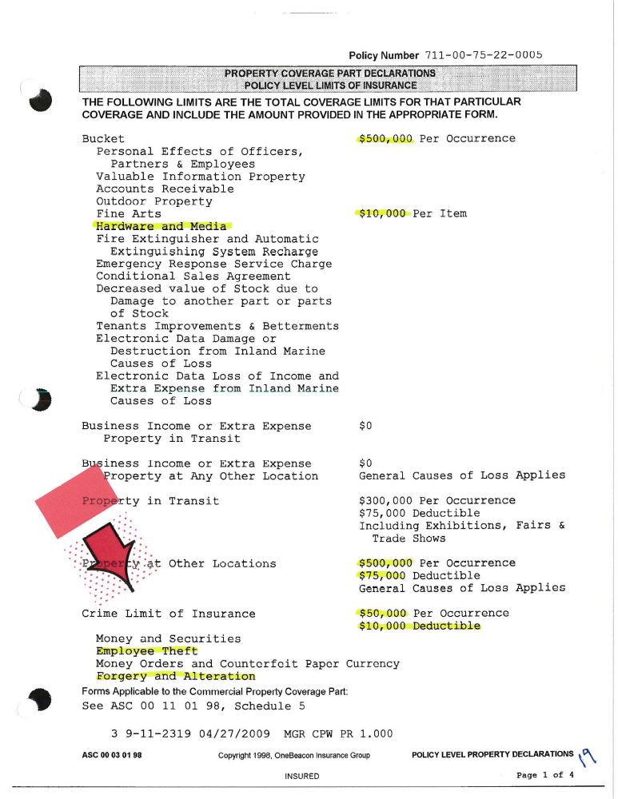

Employee Dishonesty in the News
A tearful San Francisco Giants payroll manager who admitted embezzling $2.2 million from the baseball team was sentenced to 21 months in federal prison Monday after a hearing in which the Giants opposed her request for leniency.
Robin O'Connor, 42, of American Canyon, who worked in the Giants' front office from 2007 until her arrest last July, pleaded guilty in November to defrauding the team by transferring money to her bank accounts in numerous transactions between June 2010 and June 2011.
She has paid back $960,000 and was ordered Monday to pay an additional $1.456 million to the Giants, which includes more than $200,000 for the team's costs of investigating her. She will also forfeit a 2011 BMW and a Ford pickup truck, which prosecutors said she bought with stolen money.
Federal sentencing guidelines called for a prison sentence of 33 to 41 months, and prosecutors sought 33 months.
But O'Connor's lawyer, Rita Bosworth, an assistant federal public defender, argued for probation and a year of house arrest. She said the crime was an aberration, O'Connor is deeply remorseful, and her husband would take the couple's autistic 6-year-old son and his 5-year-old brother to his native England if his wife went to prison.
O'Connor, her voice shaking, apologized to the court, her family and friends, and the Giants, "an organization that I loved." But a lawyer for the team argued for a longer sentence, saying O'Connor had betrayed the Giants' trust and was slow to admit her thefts.
"The Giants contest very, very strongly that (O'Connor) has accepted responsibility," said attorney Sharon Bunzel. She said the former payroll manager caused "a fair amount of havoc" for the team and still hasn't accounted for more than $500,000.
U.S. District Judge James Ware imposed the 21-month sentence recommended by the court's probation office, saying the crime was too serious to avoid imprisonment. He gave O'Connor until June 11 to turn herself in.
Bob Egelko is a San Francisco Chronicle staff writer. begelko@sfchronicle.com



Utility Services Interruption
What is this Coverage For?
Loss of power can be caused by many perils, wind, ice, fire, lightning, collision, etc. This coverage can pick up direct damage (physical damage to your property caused by an off premises utility interruption) and indirect damage, (business interruption and or extra expense caused by an off premises utility interruption) both of which are excluded without the addition of an off property coverage endorsement.
When you think about utility interruption there are three main areas to consider:
- Water Supply

- Communication Supply
- Power Supply

Know Your Coverage
There are many factors that go into determining an adequate Utilities Interruption Limit, whether it is for direct physical damage, or even indirect damage to your property. Before you can decide what is right for your business, you must first understand what is, and is not covered under your typical insurance policy.
Using the steps listed below, you can properly determine the appropriate coverage limit:
- No coverage for overhead transmission lines
- A sub limit for a minimal amount of coverage typically applies
- They may have direct coverage but no coverage for indirect damage
- The type of utility power or service—electricity, water, steam, etc.—may have to be listed or described on the policy.
- The extension may contain a distance requirement where insured physical loss or damage to the utility’s property must occur within a specific distance of the insured’s premises affected; one mile and five miles are common.
Additionally, insured’s think, because they have business income coverage, they are covered; we understand that this is not true because BI requires there be a direct physical damage to insured property and since the utility property is not the insured’s property, damage to the utilities property would not trigger a claim.
Understanding the exposures to loss relative to the type of utility is critical in order to evaluate the type an extent of coverage needed.
Consequences of Inadequate Coverage
Loss not covered by the insurance policy – hit to balance sheet
No coverage in the event of a large power outage – cause by windstorm, ice storm or isolated situations as three examples. These do not happen often but when they do happen it can be significant. In many cases you can pick up more coverage for very few dollars.
Even if coverage is not available the proper understanding of these coverages are crucial, absolutely crucial toward a happy ending after a claim.

Loss is paid by YOUR
Check Book!!

Brown & Brown Recommendations
After reviewing your current policy, I have determined that you do in fact have some coverage for utility interruption for your business. Your policy will pay for direct physical damage to your property caused by utility interruption up to a limit of $1,000,000, subject to a $100,000 deductible. However; your policy does NOT provide you coverage for Overhead Transmission lines causing the interruption, and it does not provide you coverage for any indirect damages.
During our conversations, you told me that almost 50% of your $750,000,000 revenue comes out of your Florida location, the lightning capital of the world. Can you imagine the amount of money you would lose each day your business is down due to a utility interruption? Whether it is from a windstorm, or a hurricane, or lightning hitting a power sub-station, are you comfortable with the amount of converge provided by your current insurance agent?
We recommend a true understanding of your exposure, and increasing the limits at prime locations. Overhead Transmission Lines is an issue that cannot be excluded!!!
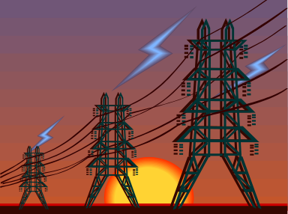
Average Daily Revenue from Melbourne facility - $1,000,000

How long can you afford to be down?

Utility Interruption in the Current Policy

Utility Interruption in the News

This is an excerpt of the article, the whole article can be read: http://www.claimsjournal.com/news/national/2013/02/04/219823.htm

Lessons Learned From Hurricane Sandy
By Laurie Infantino and Marjorie L. Segale | February 4, 2013
Hurricane Sandy is said to be the most damaging hurricane recorded in U. S. history. There appears, however, to be some dispute as to whether Hurricane Katrina holds that dubious honor.
The cost of the storm, estimated by private firms including Price Waterhouse Coopers and the PFM group, indicates that Hurricane Sandy destroyed or damaged more units of housing, affected more businesses and caused more customers to lose power.
The statistics are staggering as are the losses (both covered and not covered) that are emerging from the storm.

DEFINITION OF “STORM” AND ITS IMPACT ON INSURANCE
A storm reaches tropical storm status by reaching sustained winds of 39 MPH. The National Hurricane Center creates annual lists of names from the database of names maintained and updated by the World Meteorological Organization. If a storm causes significant damage and/or loss of life, the name is retired from the list permanently. Thus, there will be no Katrina II or Sandy II.
Power Loss
Earlier we quoted the statistic of there being approximately 7.5 million power outages throughout Hurricane Sandy’s two day assault on land. Many of these outages lasted days and weeks. There are several issues relating to insurance in terms of the power outages:
Requirement Of An Off Premises Endorsement:
In order for businesses to have coverage for either direct or indirect losses relating to power outage, the insurance would first have “off premises” or “utility coverage” on the policy. Typically, losses stemming from off premises situations are excluded on property insurance policies.
Causation Of The Power Outage:
If there was coverage on the property policies for the off premise loss, the situation that occurred off premises would have to be covered. For example, if the off premises loss were caused by a windstorm, that cause of loss is typically covered on a Commercial Property Policy or personal form. If the loss were caused by Flooding then that cause of loss is excluded and the off premises endorsement would not apply.

Off Premises Deductible:
Off premises coverage oftentimes has a “time” deductible or waiting period of 72 hours unless endorsed. This waiting period would have eliminated coverage for many of the properties that had their power back in three days or less.

Direct vs. Indirect Loss:
An Off Premises Endorsement would have to cover both direct damage and indirect to pick up a loss for Business Income.
Some Off Premises Policies Have Distance Limitations:
It must be ascertained if there is any distance indication on the policy to which the off premises is being attached. For example some policies have a 500-foot distance radius which means the source of the off premises loss must be within 500 feet of the insured’s premise.
Business Income:
Now we are talking about one of the bigger claims that will result from Hurricane Sandy and much of it will NOT be covered. Here are some of the pressure points of this coverage.
  - If the cause of loss is determined to be “windstorm” and the insured has Business Income insurance then the policy should respond from the causation point of view assuming they had direct damage.
  - The insured will have to prove that their income loss is directly attributable to Hurricane Sandy.
  - The policy has a waiting period for coverage typically 72 hours unless endorsed.
  - The policy would have to be endorsed with Off Premise coverage for the Business Income stemming from loss of power to apply.
Traditional Business Income Policies require that there be direct damage to the premises by a peril insured against for there to be any business income insurance response. However, there is talk, in the aftermath of Hurricane Sandy of what is referred to as Non-Damage Business Interruption or Non Physical Business Interruption Insurance. It is referred to as NDBI.
The storm was one of the biggest ever and the insurance story will not end soon. There is so much more we could say but best end this with a heads up to watch and see how these claims unravel.
Laurie Infantino AFIS, CISC, CIC, CRIS, ACSR, CISR is the president of Insurance Community Center, Insight Insurance Consulting
Marjorie L. Segale AFIS, CISC, RPLU, CIC, CRIS, ACSR, CISR is the director of Education, Insurance Community Center & President, Segale Consulting Services, LLC

Problematic Deductibles
Defining Deductibles
Insurance deductibles have many different purposes, and factors for being used. Whether it is used to control or reduce claim activity, allow the insured to have “buy in” alongside the insurer, or even just to reduce insurance premiums, deductibles are in every insurance policy.
IRMI defines deductible as: An amount the insurer will deduct from the loss before paying up to its policy limits. Most property insurance policies contain a per-occurrence deductible provision that stipulates that the deductible amount specified in the policy declarations will be subtracted from each covered loss in determining the amount of the insured's loss recovery.
Deductibles can be found in many different terms, and values. Examples:
- Dollar Amount
- Time Element / Waiting Period After a Loss
- Percentage of the Loss
Know Your Deductibles
Your current policy offers a wide variety of coverage limits, and sub-limits, each of which contains its own unique deductible. Below is a list of some of your more important deductibles:
- Property Claims Deductible - $100,000
- Business Interruption Waiting Period – 72 hours
- Flood Claims Deductible - $250,000
- Earthquake Claims Deductible – 5% of total insured value
- Wind / Hail Claims Deductible - $10,000,000


=

Wind Financial Headache

Consequences of Problematic Deductibles
You pay before insurance policy – hit to balance sheet
If the deductible is set to high, then the insured ends up paying more in claim deductibles than they do in insurance premiums, which defeats the purpose of the insurance program. However, if the deductible is set to low, and you do not have any claims, you are losing out on valuable premium credits set forth by the deductible program.
Mismanagement of a deductible program or lack of observation can also lead to poor coverage. Why pay a $100,000 deductible for a theft claim, if you are only receiving $10,000 in return?


Brown & Brown Recommendations
After reviewing your current policy, it is evident that the current insurance broker has not fully reviewed your insurance limits versus the deductibles attached to them. There are numerous examples of large deductibles, only to find the coverage limit at a fraction of the deductible.
Of all the examples of the poor use of deductibles, the wind/hail deductible set forth on the property limit at your Melbourne, FL location is the most absurd. The policy shows the total values for building, media, and contents at that location is just over $18,000,000, BUT has a deductible of $10,000,000! In the event of a wind claim, which is easily the most likely loss to occur in Florida, you will be dropping $10,000,000, while the insurance company will only be out $8,000,000.
What are you paying insurance premiums for?

Once Again…
Slap in the face!!

Your Current Policy Deductibles
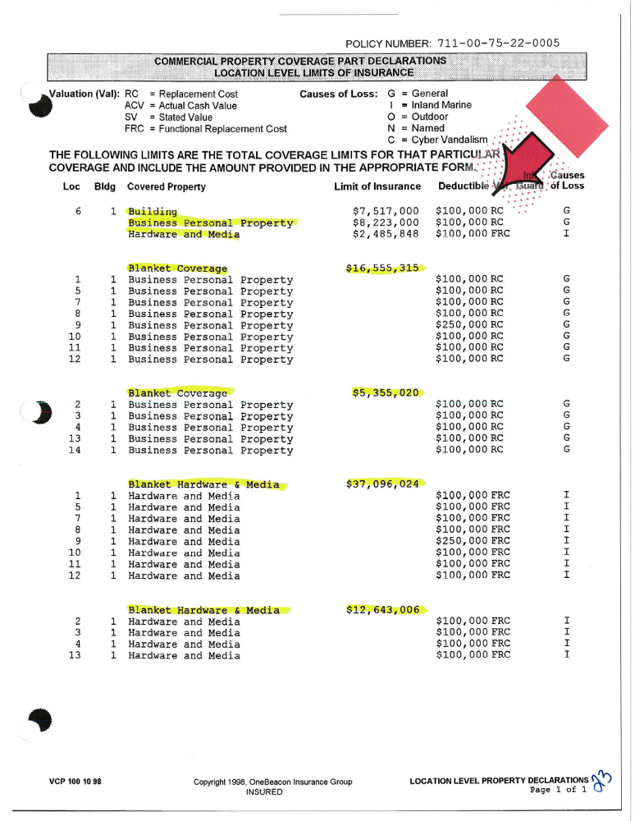

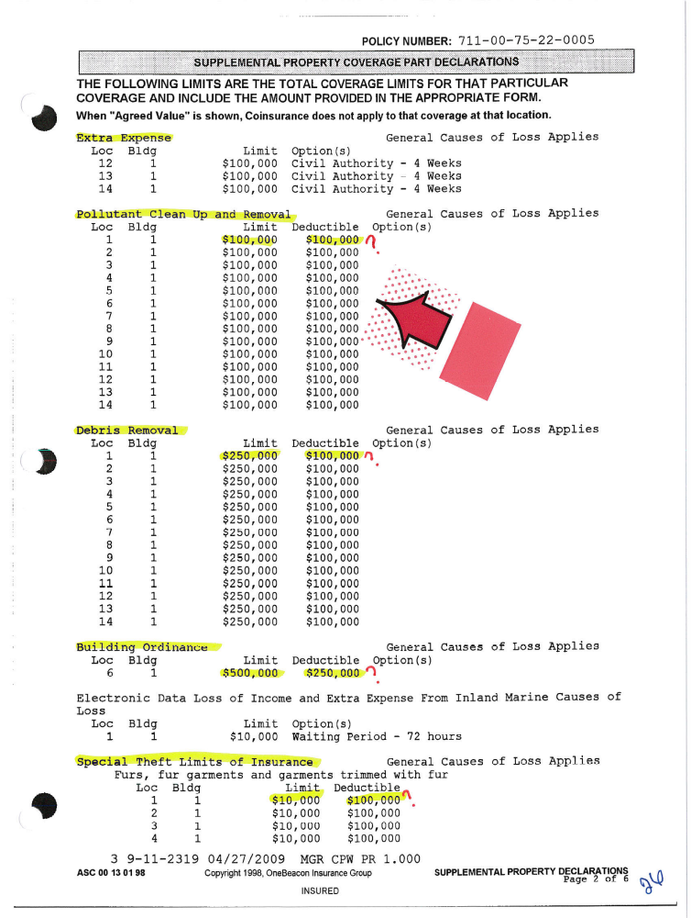

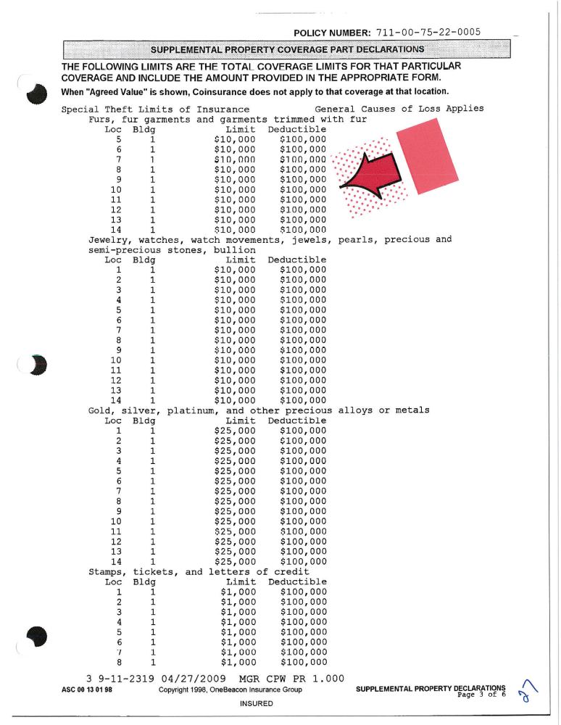

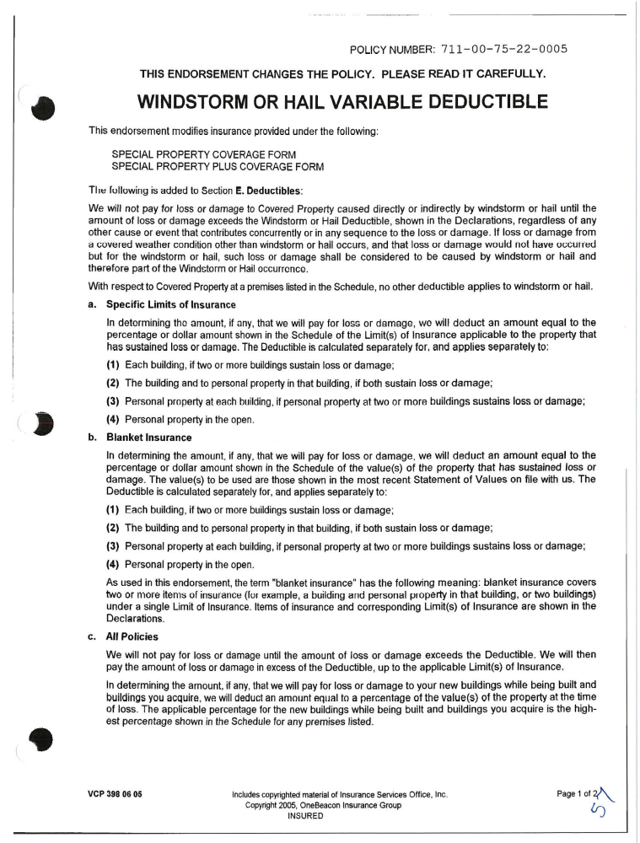

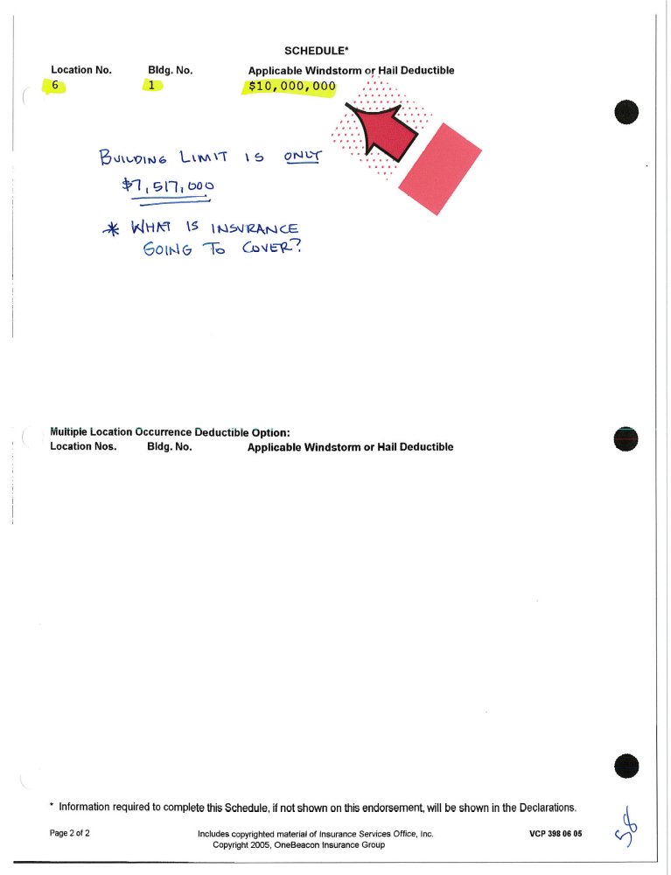
Deductibles in the News

Understanding Insurance Wind Premium Deductibles
Under Florida Statute, your insurance carrier offers it’s insured a choice in windstorm deductibles: $500.00 or 2% or 5% or 10%. Many homeowners are confused in thinking the deductible applies to the value of the loss. In fact, the deductible applies to the total insured value of the structure.
Your policy is divided into two premiums: one for damage caused by hurricane force winds and one for all other damage (all perils) such as fire. The larger the deductible, the lower the wind premium. Depending upon the home, the wind portion of your policy can be 25% to 40% of your total premium.
Florida Rule 690-170.017 provides, for those properties meeting qualification, a windstorm mitigation discount. Wind mitigation credits can reduce your premium up to a maximum of 84%. If you are not receiving wind mitigation credits or if you believe you are not receiving full credit, consider having your home inspected. Your discount may be retroactively applied up to four years! The inspector may be able to identify certain improvements which may improve your credits and thereby reduce your premium going forward.
Many homeowners have increased their deductible from 2% to 5% or even 10% due to concerns with the recent economy. Many homeowners are in peril over this. This represents a significant gamble. If your home is insured for $300,000 and you suffer a $15,000 loss due to wind and you have a 5% deductible, your out of pocket expense for the repair will be $15,000.00 – your insurance will pay nothing. This scenario will pose significant challenges to those who do not have access to the funds. Most homeowners will find it challenging to secure any type of home equity funding or home improvement funding at present due to the declining values of real estate. How will you get the home dried in and protected from mold? You should also be aware most homeowner policies exclude mold or limit the claim for mold to $1,000.00. Mold is a severe threat to water damaged homes in Florida and abatement can be expensive.
Homeowner’s are advised to review their policy and make sure they understand their deductible. Determine what wind mitigation discounts they are receiving. Have your home inspected for wind mitigation to determine if additional credits are available (additional credits may offset the cost to lower the deductible). Have the exterior and roof evaluated for weatherization and correct any deficiencies which may enhance the chance of wind/water penetration.



